Time: 2 hr

Guidelines

Must read the problem statement thoroughly before start working .
Create java project using Eclipse only
Create all java classes in package “com.itech” in src folder of created java project
Must follow the class outline as shown in figure
Must follow java coding standards
Make sure your java project must be free from compilation error ,ie. zero compilation error .In case of any compilation error reported ,the project is rejected , will not considered for assessment.
Create a new workspace/folder with name PS-JAVA in Drive C: /Users/Ur name
Select that workspace and Create java project with name PS_Name(eg. PS_Rohinth.zip)
Copy that project once you have completed to desktop,zip the folder ( eg. PS_Rohinth.zip), mail it

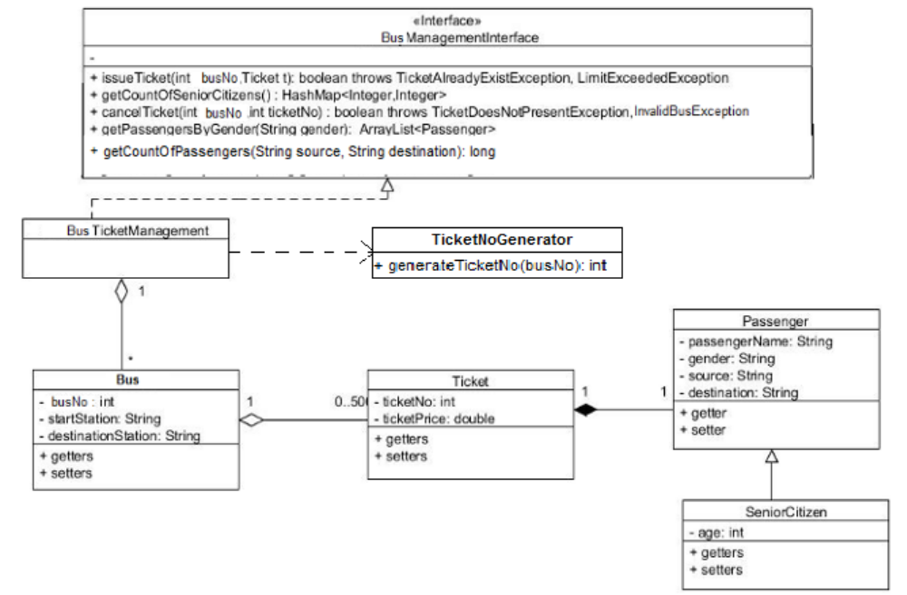

TicketNoGenerator : It is a utility class to generate the ticket number for a bus by increment one to the last ticket number. If there is no ticket allotted in a bus it needs to start with 1.

Implement the following behaviors;

1) boolean issueTicket(int busNo, Ticket t)
This method will add the given ticket to the given bus and returns true. If the same ticket is already
issued to the Bus, TicketAlreadyExistException should be thrown. A Bus can have maximum of 50
tickets. If it exceeds that LimitExceededException should be thrown. If the given busNo is not
present, method should return false.

2) HashMap<Integer, Integer> getCountOfSeniorCitizens()
This method will return a HashMap with busNo as key and value will be the count of SeniorCitizens
who booked that bus's ticket.

3) boolean cancelTicket(int busNo, int ticketNo)
This method will remove the given ticket from the given bus. If the given busNo is not present, throw
InvalidBusException. If the given ticket is not present in that bus throw TicketNotPresentException.

4) ArrayList<Passneger> getPassengersByGender(String gender)
This method will return all the Passengers belonging to the given gender in
BusManagementSystem. In Tester class, sort the list based on name and display it.

This method need to write in the paper.
5) long getCountOfPassengers(String source, String destination)
This method will return the numbers of passengers traveling between the mentioned two stations in all the buses.

Zip Procedure:

1. In eclipse right click on your project.

2. Select copy, then on desktop paste it.

3. Now, on desktop your project folder will be available. Right click that folder and select, send to -> compressed folder.

4. Now you can find compressed file (zip) of your project folder.

